**I am try to setup agora SDK   
  
but when I run project showing error..**

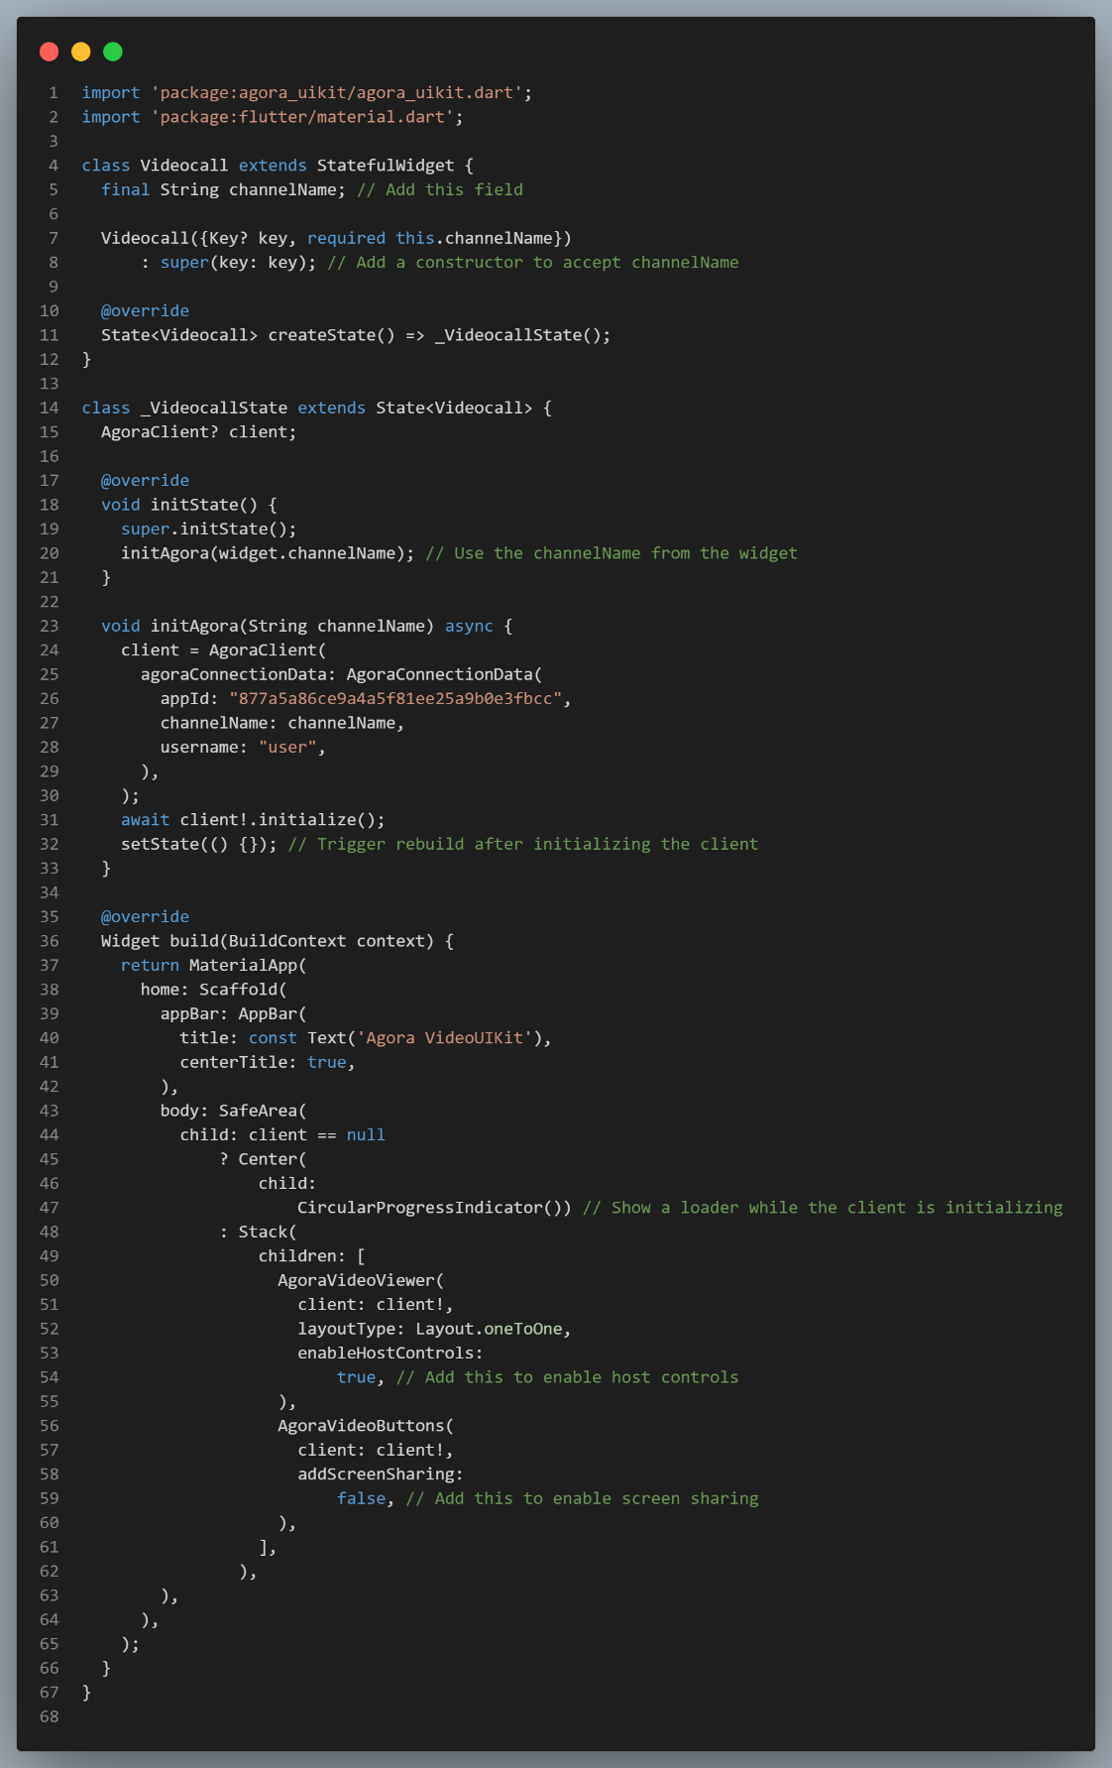

**But Whenever I run This code showing error**

**C:/Users/sayya/AppData/Local/Pub/Cache/hosted/pub.dev/agora_rtc_engine-6.5.0/lib/src/agora_rtc_engine.dart:1648:9: Context: Found this candidate, but the arguments**

**don't match.**

**const RtcEngineEventHandler({**

**^^^^^^^^^^^^^^^^^^^^^  
  
  
  
please suggest me any solution Or any mistake.**